This document is for planning purposes only. You will need to complete the online application to be considered for funding.

Overview
- To be eligible to receive grant funding, your school must participate in the National School Lunch Program; additional consideration will be given to schools that also participate in the National School Breakfast Program.
- Schools will be evaluated to receive grant funding based on a variety of factors including the strength of the program, enrollment, Free and Reduced rate, and potential for dairy sales impact with equipment investment.
- Grantees are expected to implement the service model and equipment no later than January 31, 2027.
- GENYOUth will ship all equipment packages in the fall of 2026. The district/school will assume ownership of the equipment once delivered and is responsible for all maintenance and future disposal, as needed.
- All applications will be reviewed, and approvals/notifications will be made by mid-April 2026.

Equipment package options include:
Option 1: Steel Curtain Chill Pack – Barrel Cooler and 2 Wire Carts w/ 3 Bags & 3 Bins
- Barrel Cooler keeps beverages cold for up to 24 hours and requires no electricity!
  - Dimensions: 26” diameter - 32” height
  - Capacity: 140 ½ pint cartons or 80 12oz cans (in two 12”x12” milk crates)
  - Weight: 75lbs unloaded ~ 130lbs fully loaded
  - 4 cold panel inserts
  - Heavy-duty casters for smooth rolling
- Two 4-Level Wire Carts featuring 4 levels for food display designed to fit standard trays already used in lunchrooms and are delivered fully assembled!
  - Dimensions: 36”W x 18“D x 72”H
  - Weight: 50lbs unloaded ~ 250lbs fully loaded
  - 2 graphic side panels
  - 3 insulated bags with zipper tops and name plates for labeling
  - 3 bins
  - 360˚ swivel and locking wheels

Option 2: Black and Gold Showcase Kit – Serving Cart w/ Signage Set and 2 Wire Carts w/ 3 Bags & 3 Bins
- One 3-Tier Rolling Cart has stainless steel top, chrome wire shelves, and a custom front graphic panel
- Dimensions: 48”L x 18.25”W x 40”H
- Weight: 50lbs unloaded
- 360˚ swivel and locking wheels
- Two 4-Level Wire Carts feature 4 levels of food display area designed to fit standard trays already used in lunchrooms and are delivered fully assembled!
- Dimensions: 36”W x 18“D x 72”H
- Weight: 50lbs unloaded ~ 250lbs fully loaded
- 2 graphic side panels
- 3 insulated bags with zipper tops and name plates for labeling
- 3 bins
- 360˚ swivel and locking wheels

Application – School Information Tab

Contact Information
*Your Name:
*Your Title:
*Your Email:

School Nutrition Director – This person will be responsible for implementation and reporting.
*School Nutrition Director Name:
*School Nutrition Director Email:
*School Nutrition Director Phone:

School Information
*District Name:
*District 9-Digit Federal Employer Identification Number (XX-XXXXXXX):
Note: This is a 9-digit number in the following format XX- XXXXXXX. Also called the Tax ID Number or the Federal EIN. It is NOT the same as a tax-exempt number or State EIN. Please contact your district's business/finance department for more information.
*School Name:
*School Enrollment:
Shipping Address (where the equipment should be delivered):
Note: Please check the dimensions of each item in the requested equipment option to ensure it can be received.
*Building Name:
*Attention:
*Address Line 1:
Address Line 2 (optional):
*City:
*State:
*ZIP Code:
* Does the building listed above have a loading dock/liftgate or a doorway accessible by a ramp? [Yes/No]
*Does your school participate in the National School Lunch Program? [Yes/No]
*Does your school participate in the National School Breakfast Program? [Yes/No]

Application – Program Information Tab

Program Information
* Please review the equipment package details and select your desired option: [Steel Curtain Chill Pack, Black and Gold Showcase Kit]
*Anticipated program start date: [mm/dd/yyyy]
*Total number of service days in the school year:
*Provide a detailed description of how the equipment will be utilized: [Note: 1,000-character limit]
*If there were to be changes to your operations during the current school year, please explain your contingency plan for utilizing the equipment funded by this grant & program opportunity: [Note: 1,000-character limit]

Does your school:
- *Have an afterschool/weekend feeding program? [Yes/No]
- *Have a summer feeding program? [Yes/No]
- *Have a school pantry? [Yes/No]
*Please note which of the following you will commit to in recognition of the grant:
- Social media outreach
- School newsletter
- Provide GENYOUth with pictures of equipment being utilized
- Other – please describe

Application – Guidelines & Terms Tab

Guidelines and Terms

Eligibility Requirements and Evaluation
- To be eligible, your school must
  - be located in the state of Pennsylvania, and
  - participate in the National School Lunch Program.
- Schools will be evaluated based on a variety of factors including the strength of the program, National School Breakfast Program participation, school enrollment, Free and Reduced rate, and potential for dairy sales impact with equipment investment.
- Decisions will be communicated by mid-April 2026.

Approval Requirements and Equipment
- If the application is approved:
  - Your school must comply with all reporting requirements where you will be asked to document prior school meal metrics as well as the use and impact of the equipment on future school meal metrics (See Grant Reporting section below).
  - The service model and equipment should be implemented no later than January 31, 2027.
- Equipment packages will be shipped in the fall of 2026. Once delivered, the district/school will assume ownership of the equipment and is responsible for all maintenance and future disposal, as needed.

Grant Reporting Requirements
Reporting data will be collected for April 2026 and April 2027 at the end of the 2026-2027 school year.
The specific school meal metrics that will be collected are:
- Number of Serving Days for each month (April 2026, April 2027)
- School Enrollment
- Number of students eligible for Free and Reduced meals (not a percentage)
- Average Daily Participation (ADP) for Breakfast
- Average Daily Participation (ADP) for Lunch

Schools & Reporting Tab (not on application)
[If your grant application is approved, you will be asked to supply school meal data as shown below. This section is provided for purely informational purposes and does not appear on the application.]

School Data
Please enter the appropriate school metrics for the months of April 2026 (PRE-Implementation) and April 2027 (POST-Implementation).
NOTE: "ADP" is the average number of student reimbursable meals served in a school nutrition program on a daily basis.

PRE -Implementation: April 2026
Please provide the following data for your school:
- Total Serving Days
- Enrollment
- Total Number of Students Eligible for Free/Reduced Lunch
- Breakfast Average Daily Participation (ADP)
- Lunch Average Daily Participation (ADP)
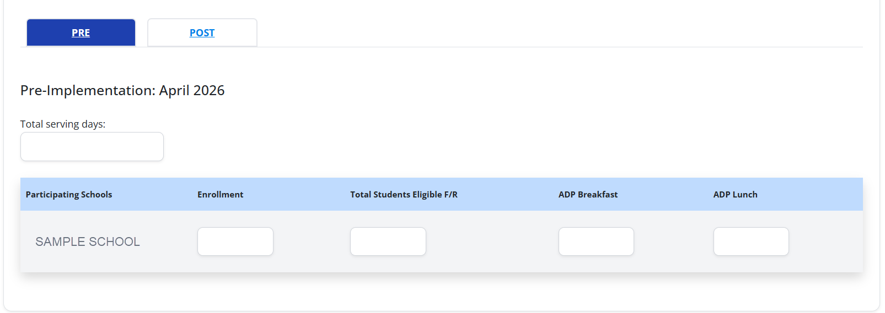

POST-Implementation: April 2027
Please provide the following data for your school:
- Total Serving Days
- Enrollment
- Total Number of Students Eligible for Free/Reduced Lunch
- Breakfast Average Daily Participation (ADP)
- Lunch Average Daily Participation (ADP)
